Publisher
1. Start a new document.
2. Insert the infographic image into the new document by clicking the “Picture” icon on the ribbon and selecting the infographic by its file name and then clicking the “Insert Button”
3. After the infographic has been inserted on the page, click the “Picture” icon again, select your logo file and click the “Insert” button.
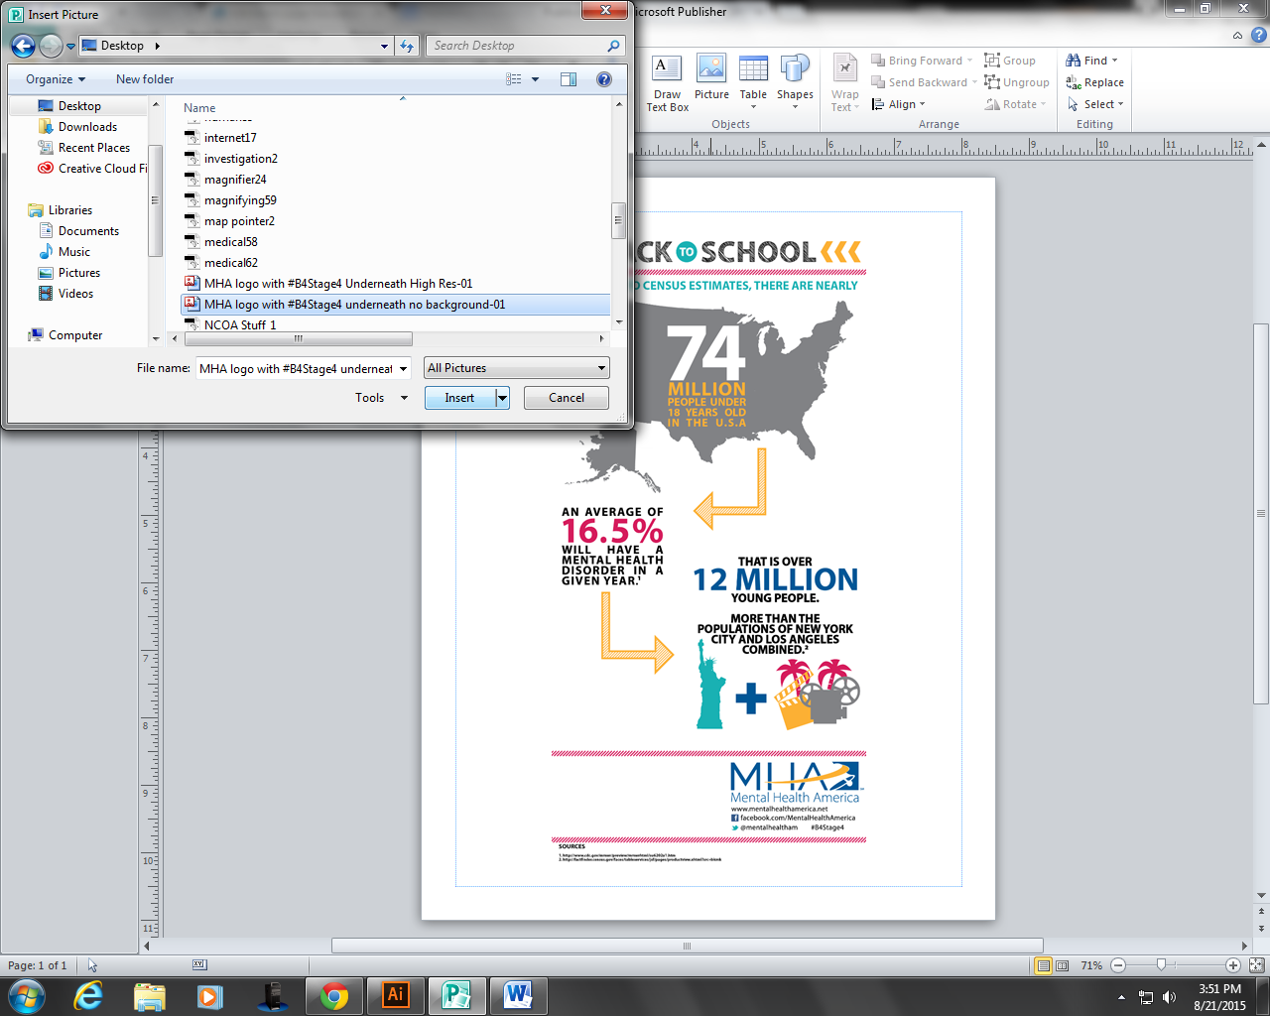
4. Drag your logo to the bottom left corner of the page beside the MHA logo. Resize your logo using the dots in the corner of the image to fit your logo into the space (use the corner dots so your logo stays in proportion).
5. To add contact info for your affiliate, insert a text box by clicking the “Draw Text Box” icon in the ribbon.

6. Type the information (phone number, website, email address, physical address, etc.) in your text box.
7. Group the infographic, your logo and your contact information. First click the infographic, then hold down the Control button while you click on your logo, then hold the control button down and click the text box with your information. Once all three are selected, click the “Group” Icon in the ribbon.
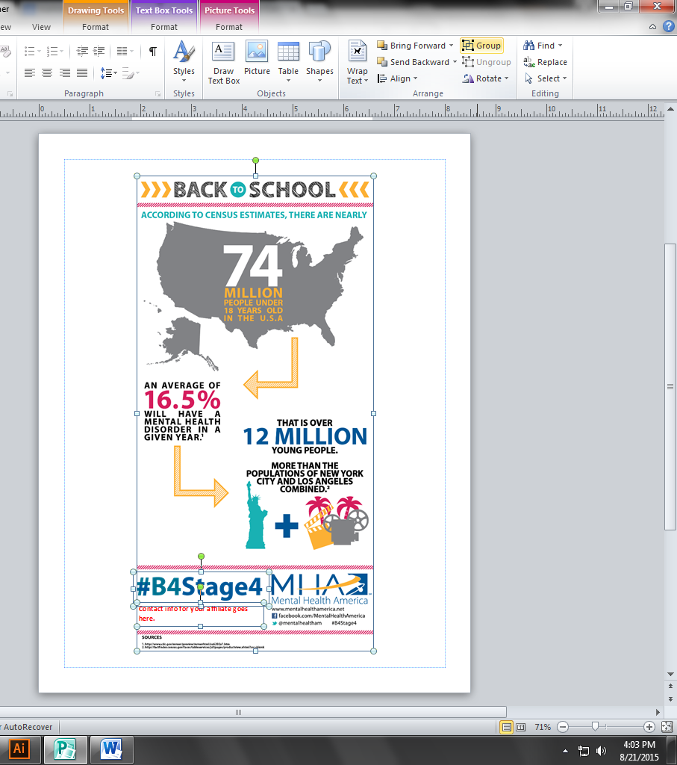

8. Now that the images and text box have been grouped, right click on the grouped image and select “Save as Picture” from the menu. Save the picture with a new name (so you know it’s the one with your logo and info). Use the new co-branded infographic on social media, web site, newsletters and other media.
