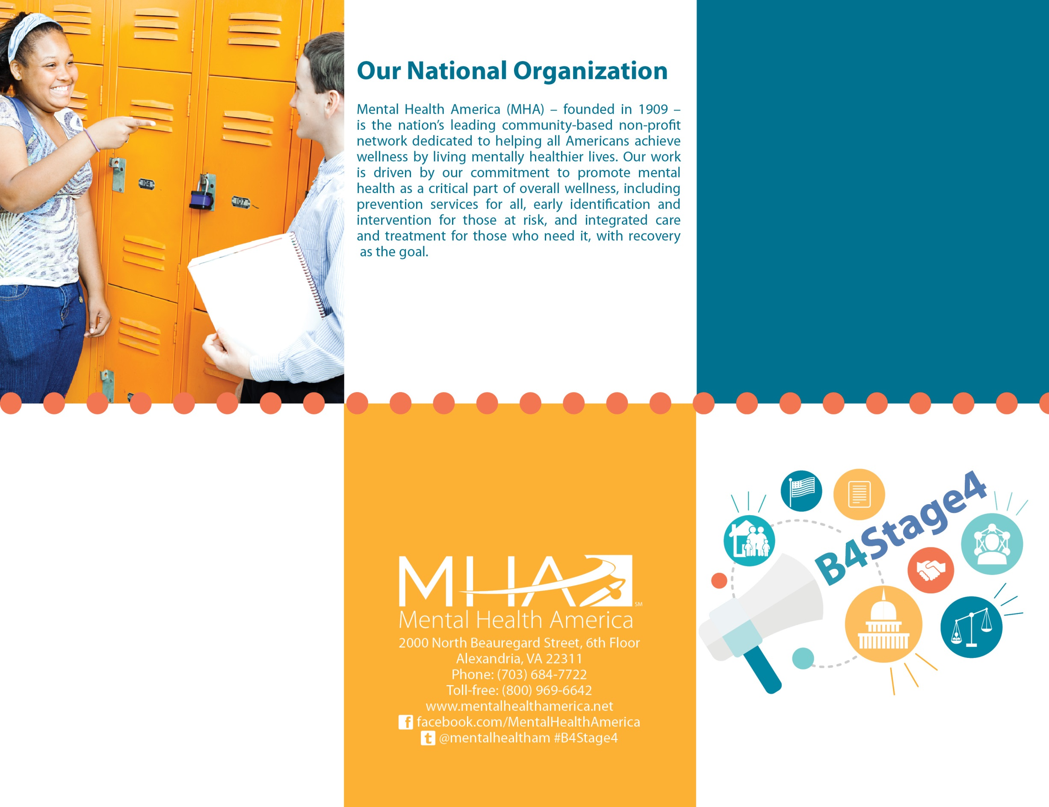

Title of Brochure

Information about your affiliate here………………………………………………………………………………………………………………………………………………………………………………………………..

Delete this text box and put your affiliate logo here by clicking insert, and then selecting the location of your logo file.



These programs tend to benefit the community in a variety of ways. Many of them reduce the prevalence of youth mental disorders, smoking, substance use, violence, teen pregnancy, and school dropout. This often also leads to reduced costs. [You can replace some of this language to reflect the efficacy of screening and follow-up to care].

Our community is better off when we invest in programs that best protect our children [when we screen often and have policies in place to guarantee access to effective and early care].

At [X] elementary school there is a classroom of children. [For adults you can use an office or the members of a community group].

Their interactions with each other, the teacher, and the larger world each have an impact on them and, over time, will influence the way in which their brains develops.

Most of these children will grow up to be happy, healthy, productive adults in our community [continue to lead healthy and productive lives in our community], but some will face challenges and need our help.

If we think about it like cancer, we don’t want to act at Stage 4, we want to catch it as soon as possible. By investing in a prevention program now, we can set these children [individuals] on a course of development that will give them the skills and resilience they need to face these challenges.

We want to act now, B4Stage4, so we can give these children the brightest possible future.

Prevention programs [or specific prevention program] train teachers, children, and staff to interact with one another in a way that helps the children build skills and resilience so they are best equipped to overcome future challenges.

Many prevention programs are [This prevention program is] evidence-based, meaning that researchers have found them to be effective in promoting positive development time and time again.

Help give our children [neighbors] and our community the brightest possible future. Visit us at URL. There you cam:

- Write a letter to a policy maker to ask that they fund a prevention program for our children [pass a policy for our community].

- Donate to the B4Stage4 Fund to help fund a prevention program directly.

- Join the B4Stage4 Community Action Group and help us in advocating for prevention.